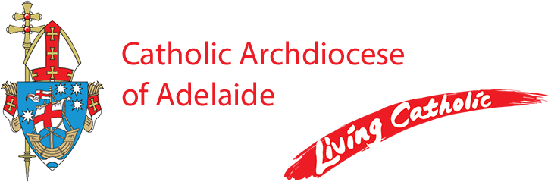

Parish Secretary

**St Davids Parish, Tea Tree Gully**

**Part-time, Monday - Friday (30 hrs per week)**

St. David's Parish is seeking a Parish Secretary to oversee administrative duties and support the smooth operation of the parish office. You will be the first point of contact for the parish, assisting with sacramental bookings, managing office systems, and supporting financial and Organisational tasks.

The successful applicant will be experienced in providing excellent office administrative support and be competent in using the Microsoft Office suite.

Excellent interpersonal and communication skills are essential together with the ability to work in a team environment.

The successful applicant will be strongly committed to the Catholic ethos.

A copy of the Position Description can be obtained by emailing Michelle Cini, HR Advisor

at [recruitment@adelaide.catholic.org.au](mailto:recruitment@adelaide.catholic.org.au)

Applications should be addressed to the Parish Priest, Fr James Jeyachandran (OMI) at [recruitment@adelaide.catholic.org.au](mailto:recruitment@adelaide.catholic.org.au)

**by 5pm on Monday 07 April 2025**

Employment with the Catholic Archdiocese of Adelaide is conditional upon a successful Working with Children Clearance and successful reference checks.

The Catholic Archdiocese of Adelaide is an Equal Opportunity Employer and a Child Safe Organization.